Adding Git Repository Credentials in Jenkins “Credential Manager”

Click on “ Manage Jenkins”

Click on “Manage Credentials”

Click on “Jenkins”

Click on “Global Credentials”

Click on “Add Credentials”

Select “Kind = SSH username with private key”

Select “Scope = Global(Jenkins, nodes, items, all child items, etc)”

Select “ID = Give an ID for the key”

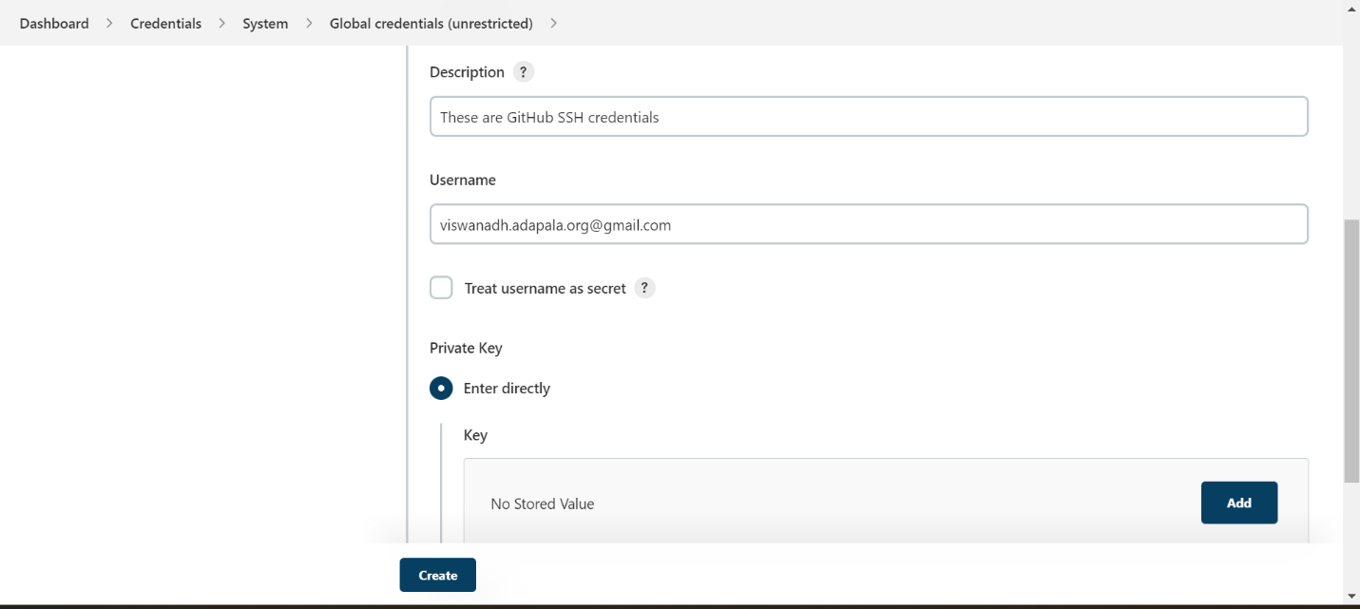

Enter Description

Enter Username

Click on “Private Key”

Click on “Add”

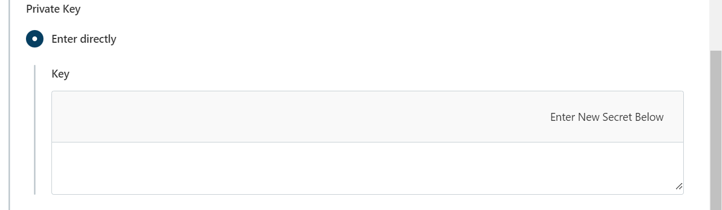

Enter the GitHub private key here.

Open git bash and read the private key

Now, read the private key “id_rsa”

Copy it and paste it.

Click on “Create”

Successfully GitHub credentials are added.